# California State University, Fresno

# DEPARTMENT OF COMPUTER SCIENCE

|  |  |  |  |  |  |
| --- | --- | --- | --- | --- | --- |
| Class: | **Algorithms & Data Structures** | | | Semester: | **Fall 2021** |
|  | | | | | |
| Points |  | Document author: | **Saishnu Ramesh Kumar** | | |
|  | Author’s email: | **saishnu_rk@mail.fresnostate.edu** | | |
| Laboratory number: | **Section 1, 11am to 12:50pm** | | |
|  | | | | | |

**1. Statement of Objectives**

Introduce the elements of this experiment. Include a description of the objectives, scope, significance, and major accomplishments of this lab. Briefly explain what is covered in this report.

**Exercise 1:**

The first exercise was for us to implement a simple stack using arrays while also using functions like push, pop, and peek to output the inputted items. Also, the scope of this lab exercise would be arrays and stack. This exercise is important as we would need to understand the concept of how stacks work, LIFO (Last in, First Out). The major accomplishment I made during this lab was me being able to understand how stack works in a code as compared to looking at diagrams of them.

**Exercise 2:**

The second exercise that dealt with linked list is what I found a little challenging as my understanding of linked list previously was not as good. This exercise mainly focused on being able to create nodes and using a linked list to travel through the various nodes. I would say that this is important because if we were to create a form of menu system or navigation system, using linked lists would be the right way to go about it. The main accomplishment I felt was that I was able to understand how linked lists work and how to code them properly.

**2. Experimental Procedure**

List the procedure used in this lab. Include how you approached the question and why.

**Exercise 1:**

The way I approached the first exercise was like any normal exercise, I read through what is required and what I would need to be doing exactly to get the specific outcome. Then I started creating the class Stack and included all the functions needed for the program, push, pop, peek, isEmpty (to check if the stack is empty) and print. I then proceeded to include the necessary code for each function and eventually called all of them into the main function to display the output.

**Exercise 2:**

For the second exercise, it took me a while to get the idea of how I would want to construct the program because I understand the concept but applying it is different. I did a little research before starting this and also by using the hints that were provided in the slides as those helped me a lot when tackling this question. For this code, I created the struct for the implementation of the node data and next pointer and then proceeded to add a linked list class to include all the functions that were needed for this question. Within those functions, I added the needed codes such as, insertion through the front, deletion of both front and back nodes, as well as the print function to output the results onto the terminal.

**3. Analysis**

Discuss the experimental results. Include the screenshots of the results.

**Exercise 1:**

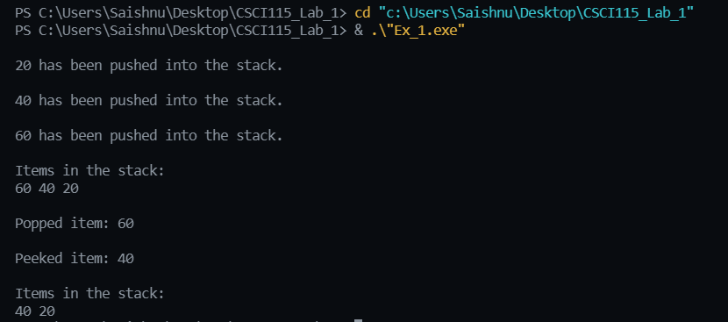

**Exercise 2:**

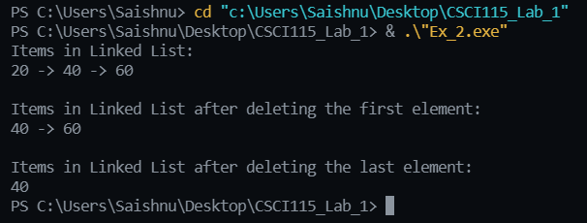

**4. Encountered Problems**

Describe the issues you faced and how you tackled them. Also, you can explain if you could not solve the issue. You should also include errors and discrepancies.

The issues I mainly faced were some compiler errors here and there but after relooking through my code and doing some research, I tried to test it out a number of times and the issues were solved.

**5. Conclusions**

Summarize your conclusions with a list of what you learnt in this lab.

From this lab, I got a better understanding of how stacks work as well as a better understanding of linked lists as before I was still unsure about it and confused. After completing this lab assignment, I feel more confident in my understanding about that topic specifically.

**6. References**

List the references used in this report.

* Lab Slides
* <https://www.geeksforgeeks.org/linked-list-set-2-inserting-a-node/>